## **Common Verbs in the Simple Past**

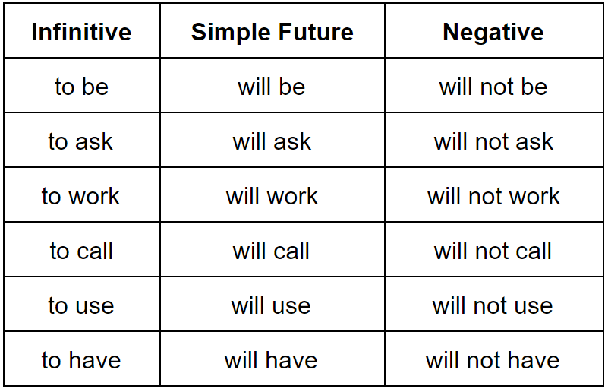

## **The “Going to” Construction**

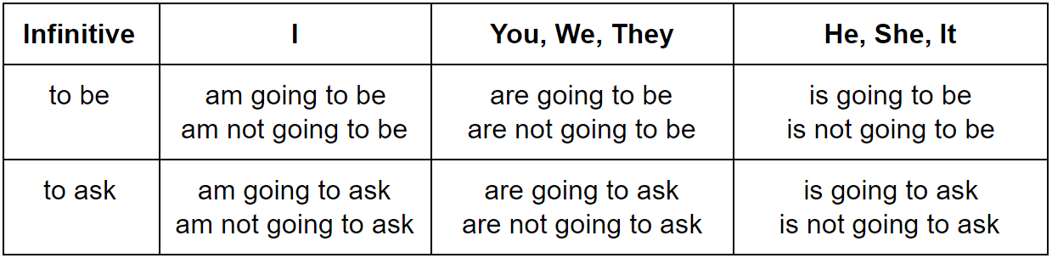

EX-1**Test will future:**

**1.**Harry / cause / trouble -> Positive: ______________________

* + Negative: _____________________
  + Question: _____________________

1. you / copy / the homework
   * Positive: _____________________
   * Negative: ____________________
   * Question: ____________________
2. the clouds / disappear
   * Positive: _____________________
   * Negative: ____________________
   * Question: ____________________
3. he / marry / his girlfriend
   * Positive: _____________________
   * Negative: ____________________
   * Question: ____________________

EX-2 Write sentences in” *going to”* future.

1. he / phone / his girlfriend
   * Positive:
   * Negative:
   * Question:
2. they / share / a room
   * Positive:
   * Negative:
   * Question:
3. the boss / sign / the contract
   * Positive:
   * Negative:
   * Question:
4. we / plant / the tree / in the morning
   * Positive:
   * Negative:
   * Question: